Installation Instructions
Wohlenberg Quad-Creaser
30mm Shaft & 98mm Outer Diameter
with a 6mm Fixed Hinge
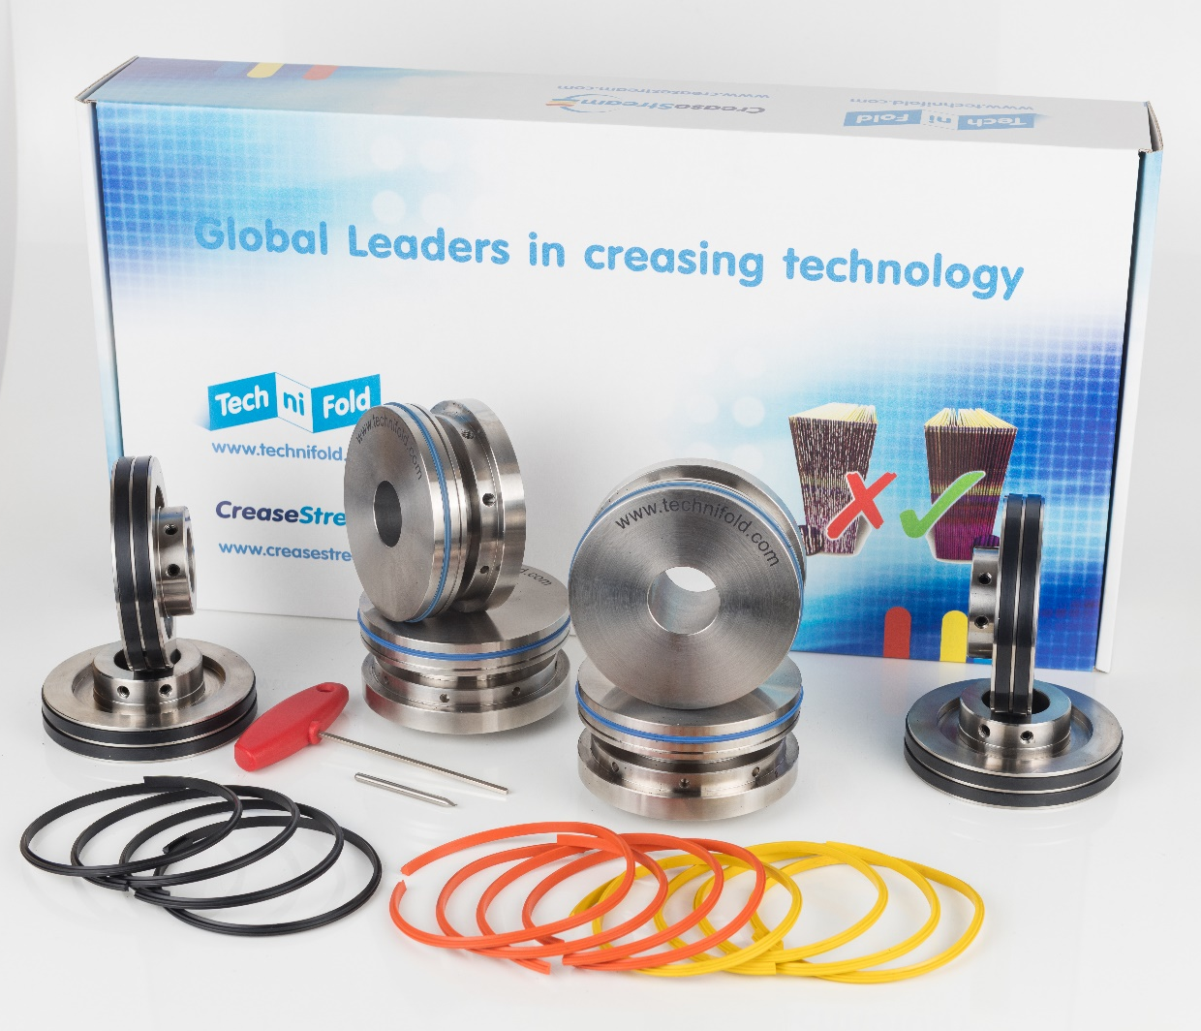
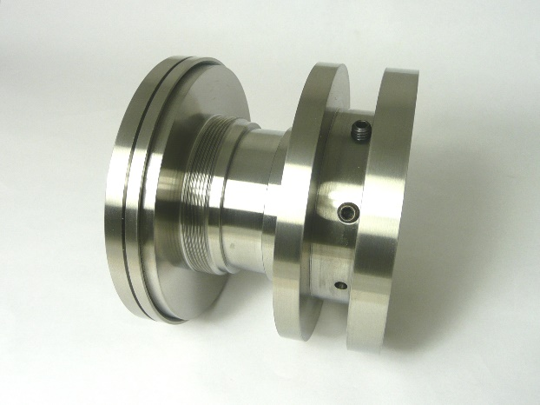
Unscrewing the 2x 6mm screws will allow the collar and mandrel parts to be separated.

REMOVING AND REPLACING THE CREASING RIBS
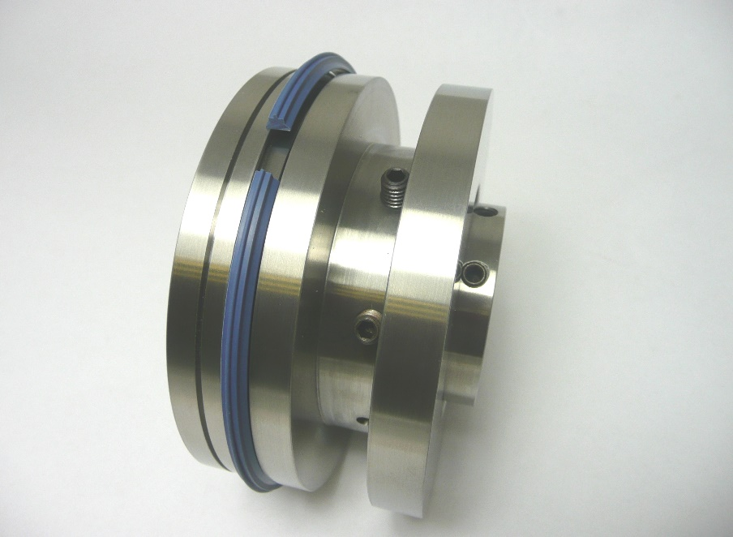
Tighten the 2x 6mm shaft locking screws to secure creasing unit into position.
With the 2x 6mm inside screws loosened, unscrew the mandrel anti-clockwise apart until the gap is large enough to remove the creasing rib entirely.

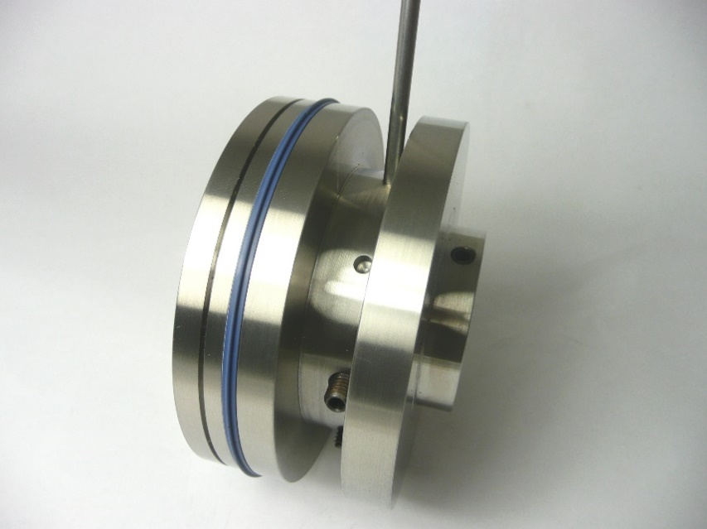
Hand screw the collar and mandrel parts clockwise together.
Place the small bar in any of the 6mm holes and tighten the two components together.
Tighten the 2x 6mm inside screws to hold and fix the two parts firmly together.

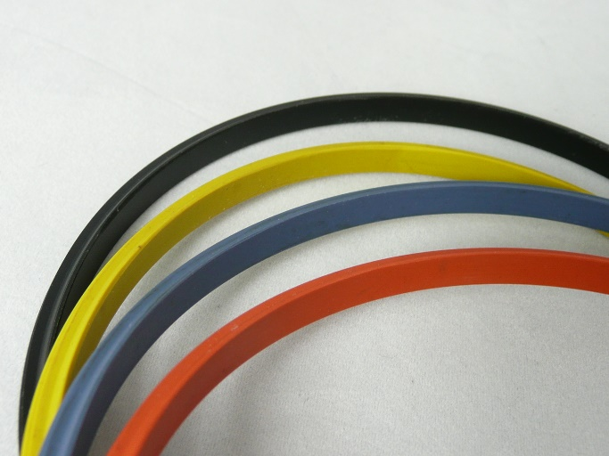
Creasing Rib Options
Orange – to crease thin cover stocks
Blue – to crease medium cover stocks
Yellow – to crease heavy cover stocks
Plastic Creasing Rib Options
Black – to crease heavy or laminate cover stocks where fibre-cracking is not an issue

TECH-NI-FOLD’S GRIPPER BOSS SUPPORT ROLLERS
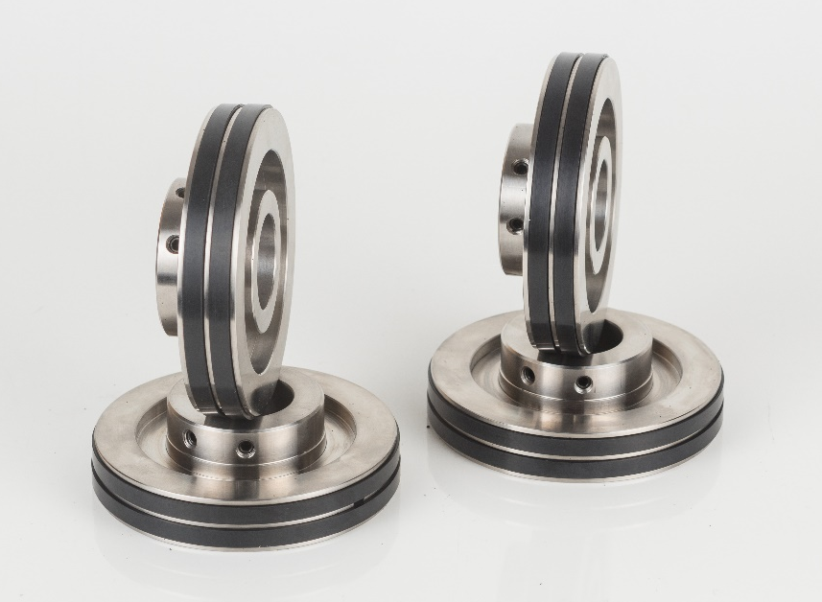
The 4x Tech-ni-Fold Support Rollers have 2 outer diameter sizes built into one roller (as shown).
Two different grip amounts can be achieved by using each gripper band separately.
Tech-ni-Fold’s Gripper Boss Support Rollers supplied in your tool pack are to be installed on the machine’s top shafts.
They are to be used in conjunction with the original plain metal support rollers which are to be situated on to the bottom shafts.
98.6mm Outside Diameter
98mm Outside Diameter

TOP AND BOTTOM COMPONENT CONFIGURATION

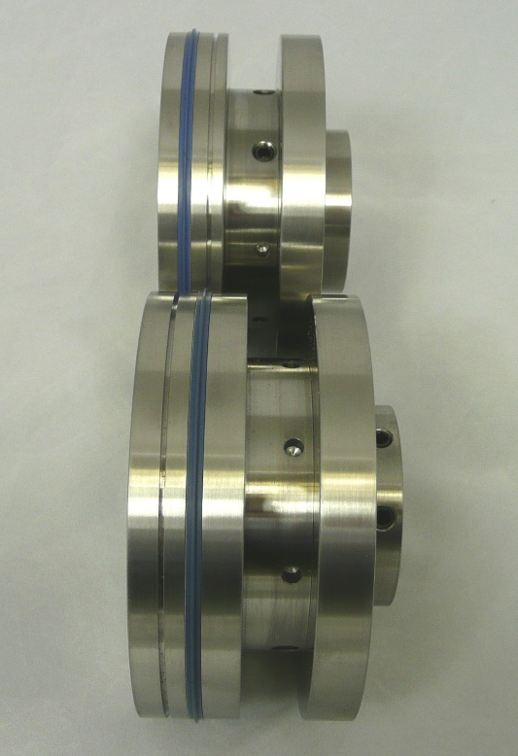
When installed within the machine, the top and bottom components will be configured as shown, with the male creasing rib and corresponding female channel aligned.
Please note: the metal diameter located on the mandrels is designed to help guide the cover stock through the device during the creasing process. They are not designed to grip the cover stock.

INSTALLING THE COMPONENTS TO THE SHAFTS
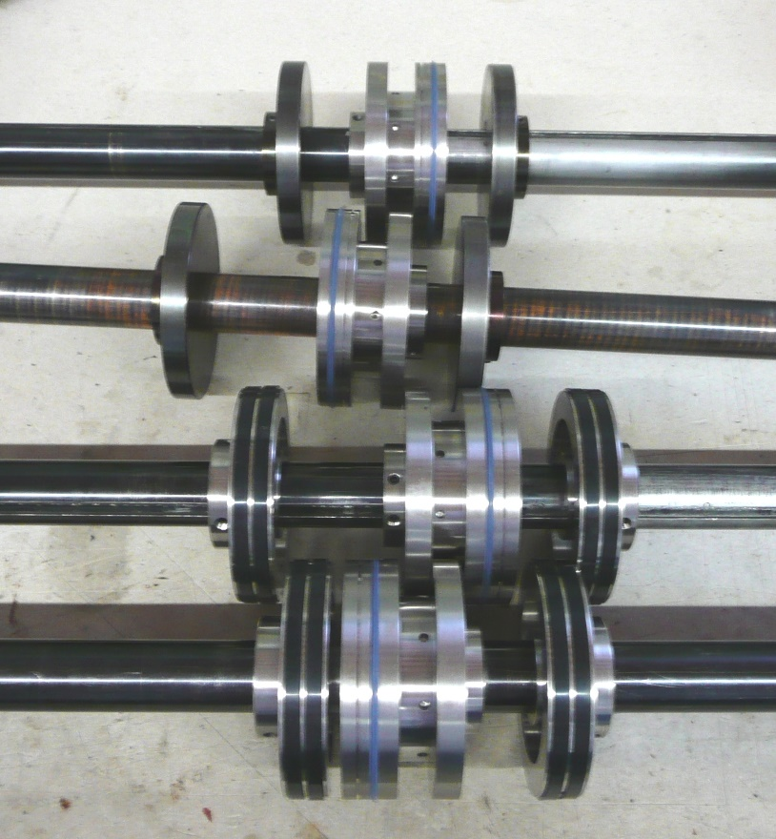
This photograph shows the assembly of the crease units before installation into the machine.
The top shafts (shown to the bottom) use the Tech-ni-Fold Gripper Boss Support Rollers.
Please note: to stop damage, please remove the creasing ribs before installation.

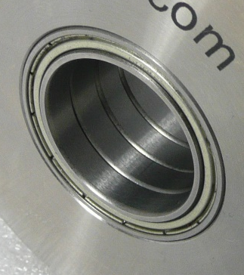
INSTALLING THE BOTTOM SHAFT COMPONENTS
It is important to use the original plain metal bottom support collars.
Select the correct colour coded split creasing ribs and attach them on to the holders.
Align a bottom crease unit with the edge of the book clamp and tighten the fixing screws.
Align the remaining crease unit into the desired position and tighten the fixing screw.
Bearings located in the inside bore of the top creasing units
INSTALLING THE TOP SHAFT COMPONENTS
It is important to use the Tech-ni-Fold Gripper Boss Support Rollers on the top shafts.
The 2x top shaft creasing units are supplied with bearings installed on the inside bore (see image right).
Once the crease units are on the shafts insert the required coloured split creasing ribs.
To achieve the correct grip between the Support Collars, align the top and bottom collars together. Equal gentle pressure should be achieved on each collar.
As the top shaft is being lowered, slide the male rib protrusions into the corresponding female channels.
Slowly run a sheet of cover stock between the creasing units. As the cover stock is fed through the crease units the loose top crease units automatically centralise to the optimum crease position.
Tighten down the fixing screws when the crease unit fixing screws come into view.
If the creasing ribs open-up during production, loosen the fixing screws on the top crease units to allow the creasing units to rotate freely on their in-built bearings.

Please note: to achieve the optimum crease quality, the creasing ribs must be located into the centre of the female creasing channels.

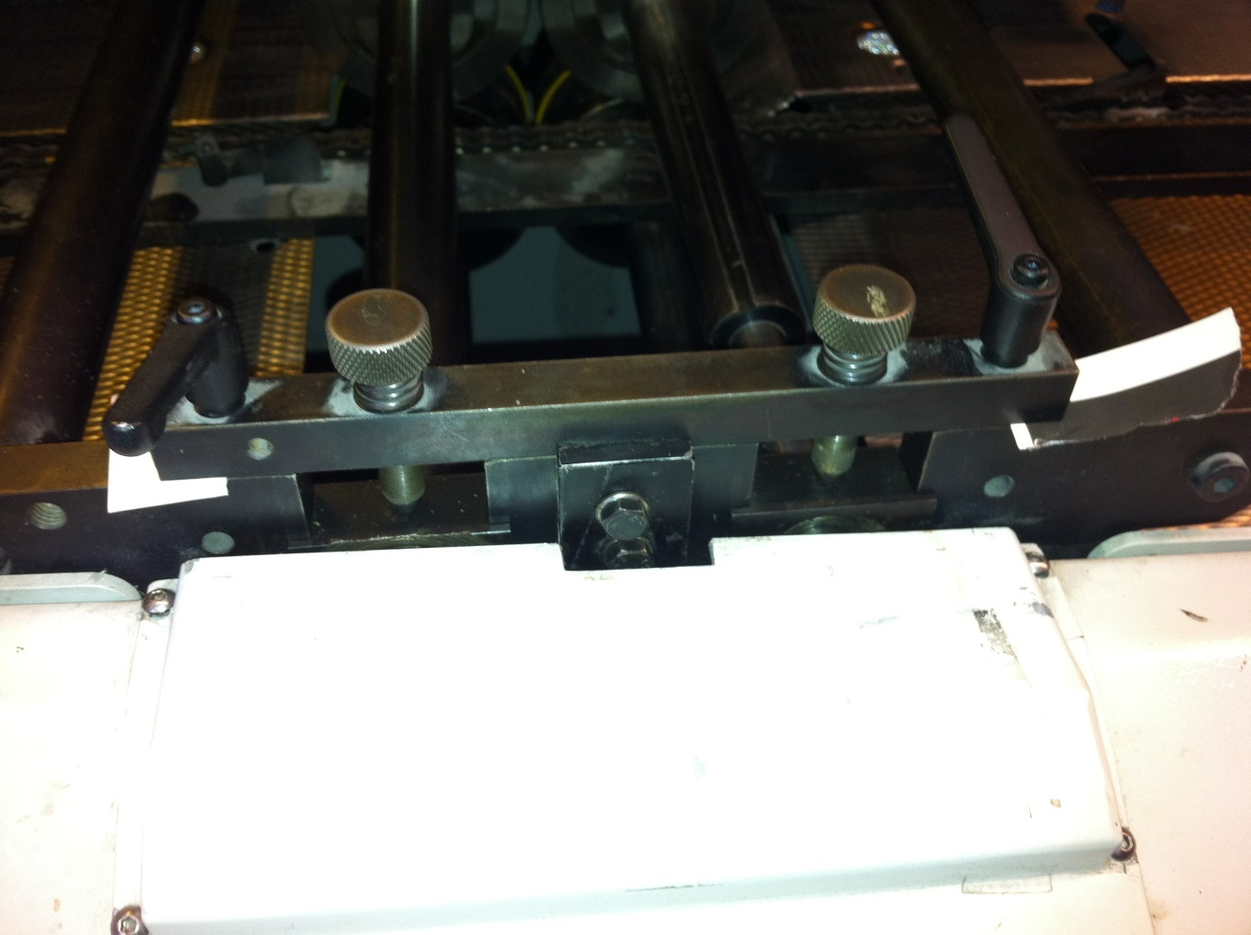
SETTING AND ADJUSTING SHAFT PRESSURES
Insert paper under calliper blocks
To finely set the calliper pressure for the first time, it may be advantageous to insert 80gsm paper between the blocks (as shown in above photograph). When setting for different weights of stock simply insert the correct stock in to the 4x calliper blocks and the shafts will automatically be set to the correct pressure.

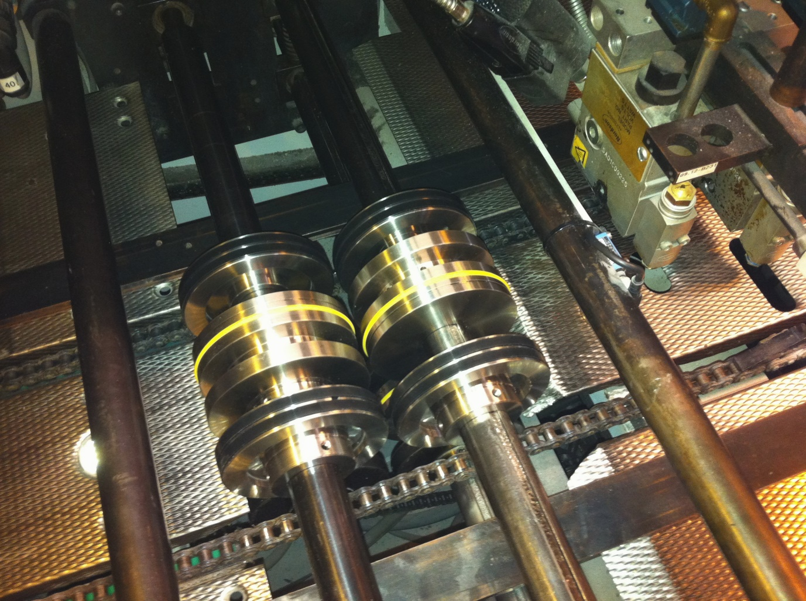
THE MACHINE IS NOW READY TO RUN

NOW AVAILABLE…
Tech-ni-Fold’s Flap Creasing Add-On
Available for Wohlenberg Binding Machines with 98mm Outside Diameter
Order Code: QC-DEL-WO/98-ENDFLAP-FP
Do you have a requirement to produce outer flap creasing on the cover stocks you put through your Wohlenberg Binding machine?
Please ask your local representative for more information on this Tech-ni-Fold Flap Creasing Add-On.
